

October 14, 2002

EDITORIALS

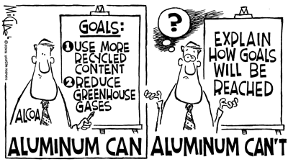

Needed next: the minutiae
Alcoa Inc. has done the responsible, proactive thing by setting ambitious recycling goals for itself and the aluminum industry. Now it needs to follow through and answer its critics’ concerns that the goals are vague enough that they could be ineffectual.

The company has set a global goal of using recycled aluminum in 50 percent of most of its products by 2020. That’s up from the current 20 percent. The company also is calling on the industry to continue to reduce greenhouse gases. Alcoa said it’s closing in on its goal of reducing greenhouse gases by 25 percent since 1990.

While applauding Alcoa’s intent, the Container Recycling Institute expressed concern about how imprecise the goals currently are. That 50 percent goal, for example, could include products with a little or a lot of recycled content, which would make a big difference in the overall recycling effect.

Alcoa says it is still developing the specifics of its plans. The company needs to keep the ball rolling by going public when it does have the specifics. That can help serve as a much better road map to other aluminum product makers.

Alcoa insists it wants to be an industry leader in this area. The company is off to a good start. It should continue to lead with an aggressive, detailed plan.

